

Validation task

Bryce grahn 12 k-1



Trinity house highschool

Examination number:

Table of Contents

Graphical user interface: 2

GUI Table: 3

Test Plan: 4

Before and after testing: 4

Coding: 10

# Graphical user interface:

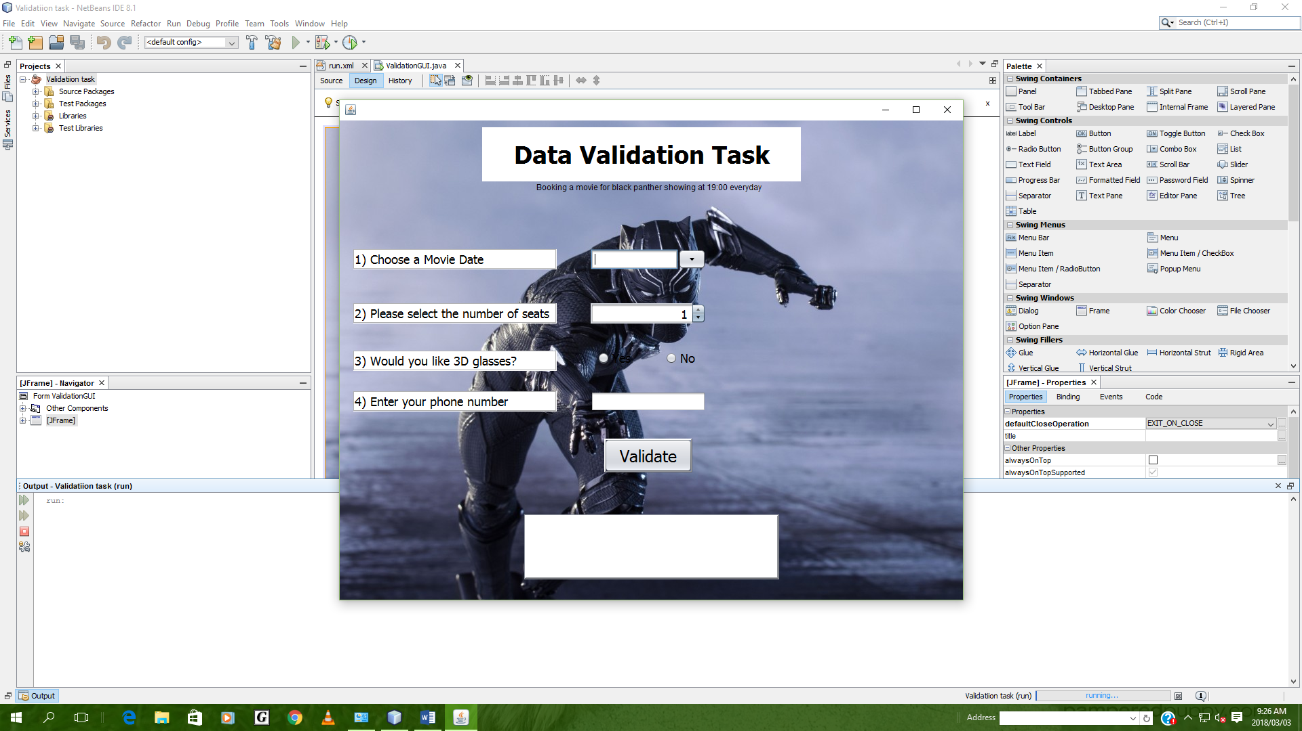

# GUI Table:

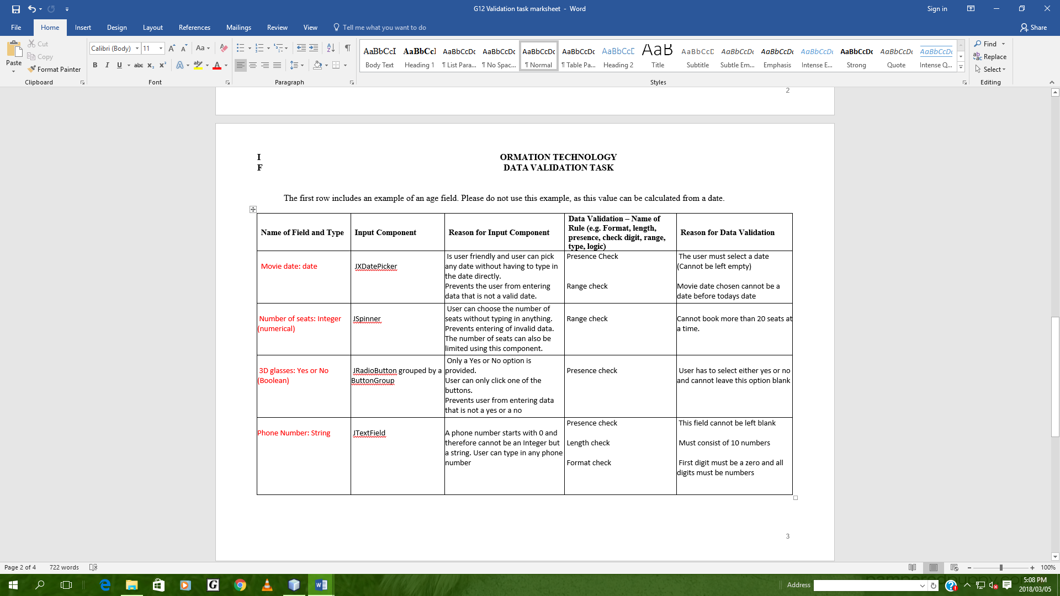

# Test Plan:

|  |  |  |  |
| --- | --- | --- | --- |
| **Name of Field** | **Standard** | **Extreme** | **Abnormal** |
| JDate | Today’s date | In a month’s time from today’s date | Past date (2018/01/03) or left blank |
| seatSpinner | 2 | 20 | 27 or left blank |
| radioButtonYes/No | yes | no | Left blank or try click both options |
| txtPNum | 0825467232 | 0800000000 | * 8812345678 * 081234 * 082345frw3   (Doesn’t start with 0, incorrect length, contains text or left blank) |

# Before and after testing:

Standard:

Before

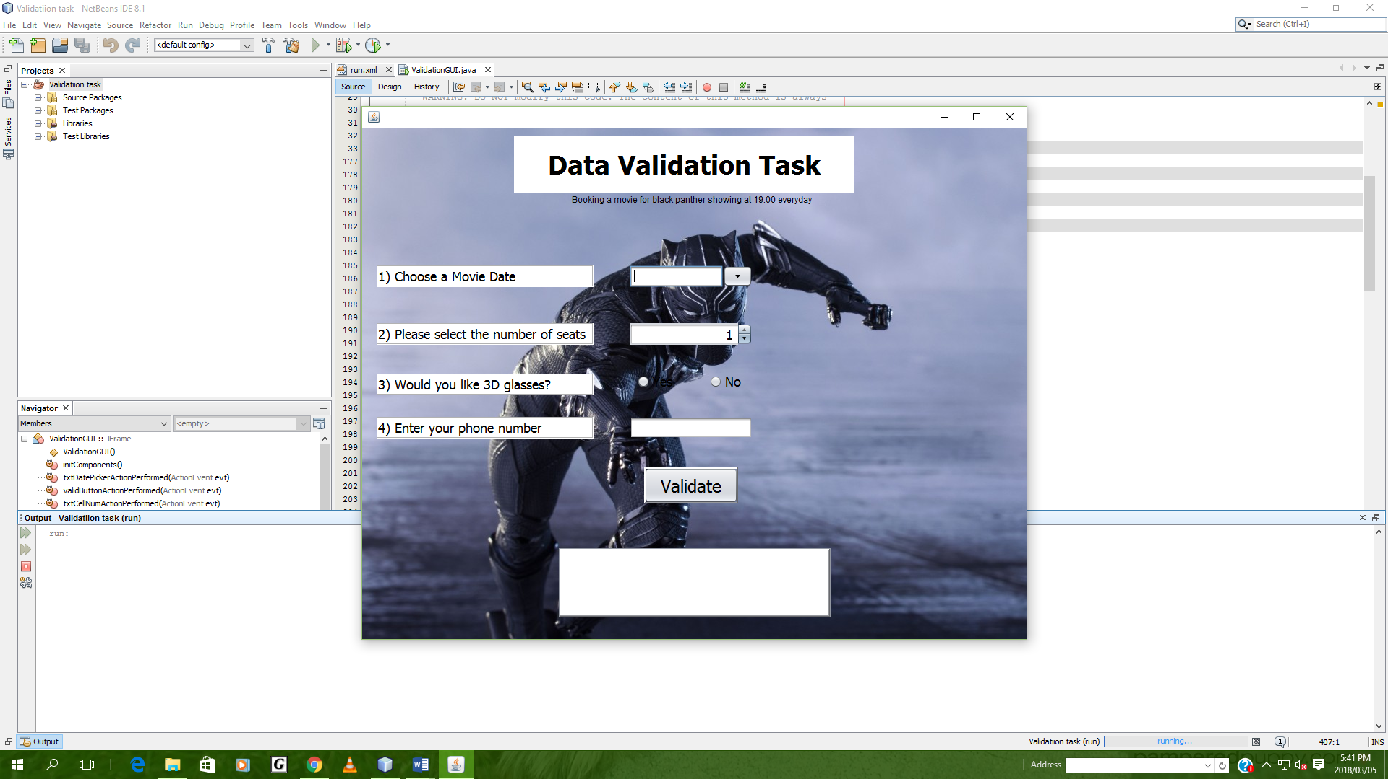

After

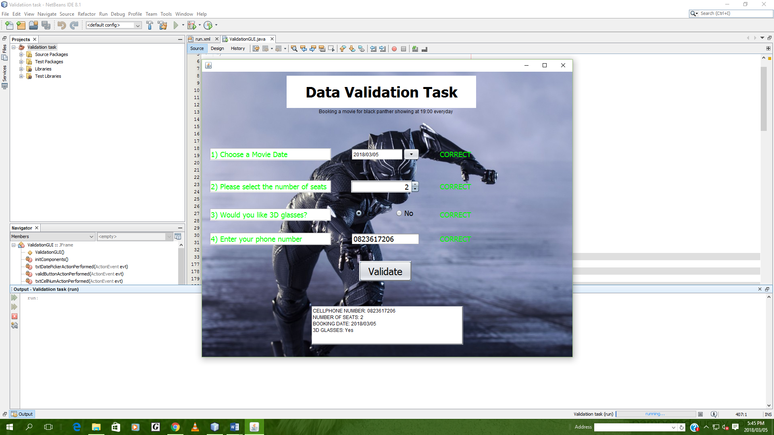

Extreme:

Before



After

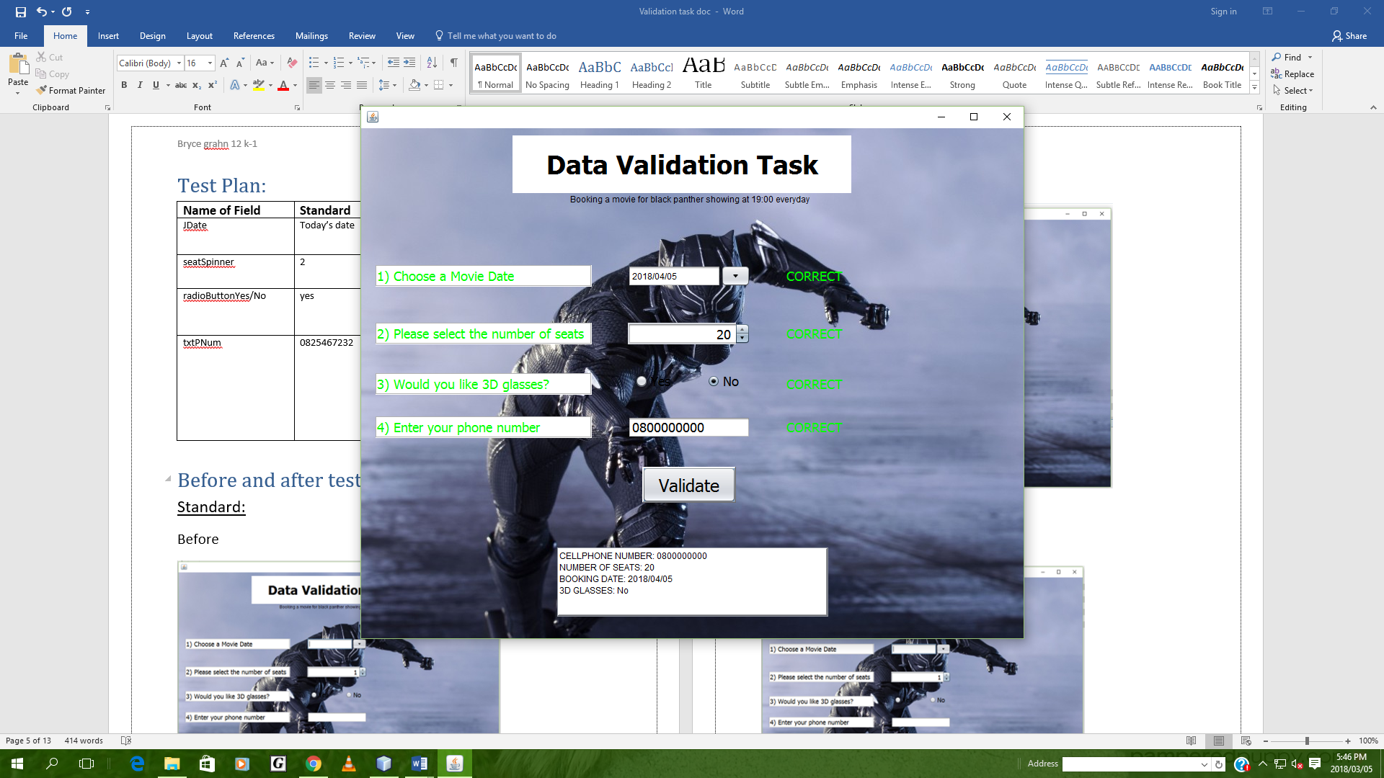

Abnormal:

Before



After

1. Presence check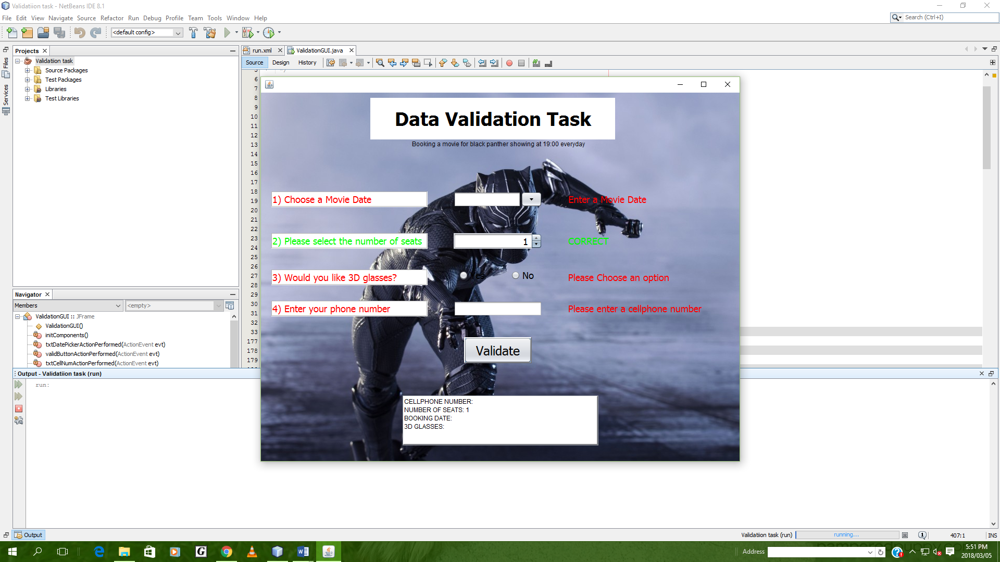
2. Range check

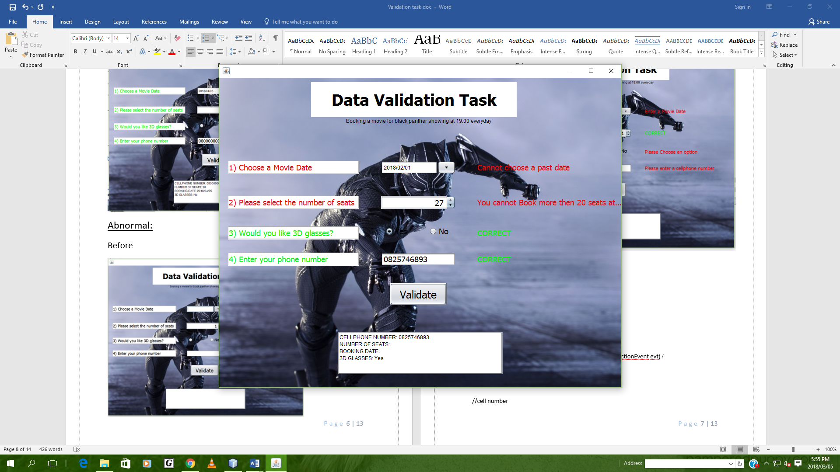

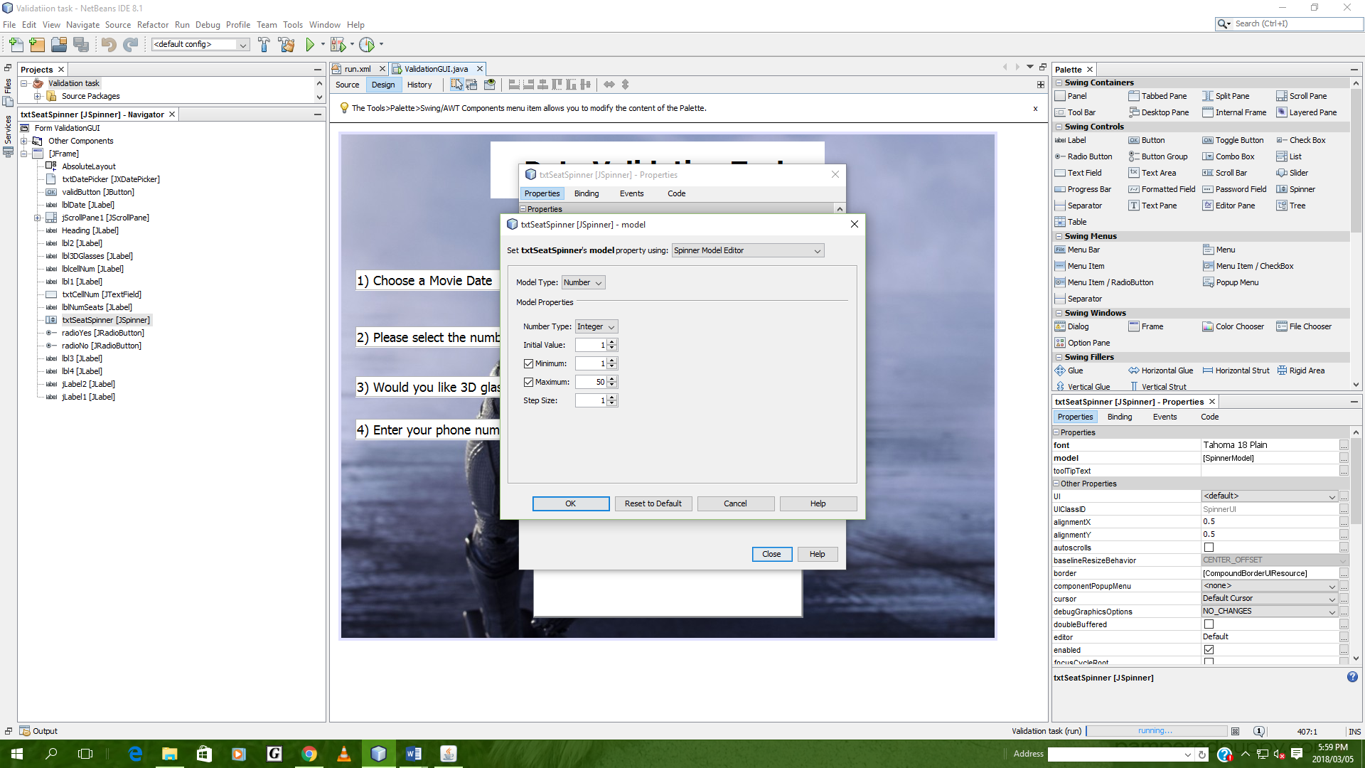

1. Format check

Button group prevents selecting of both the radio buttons at the same time

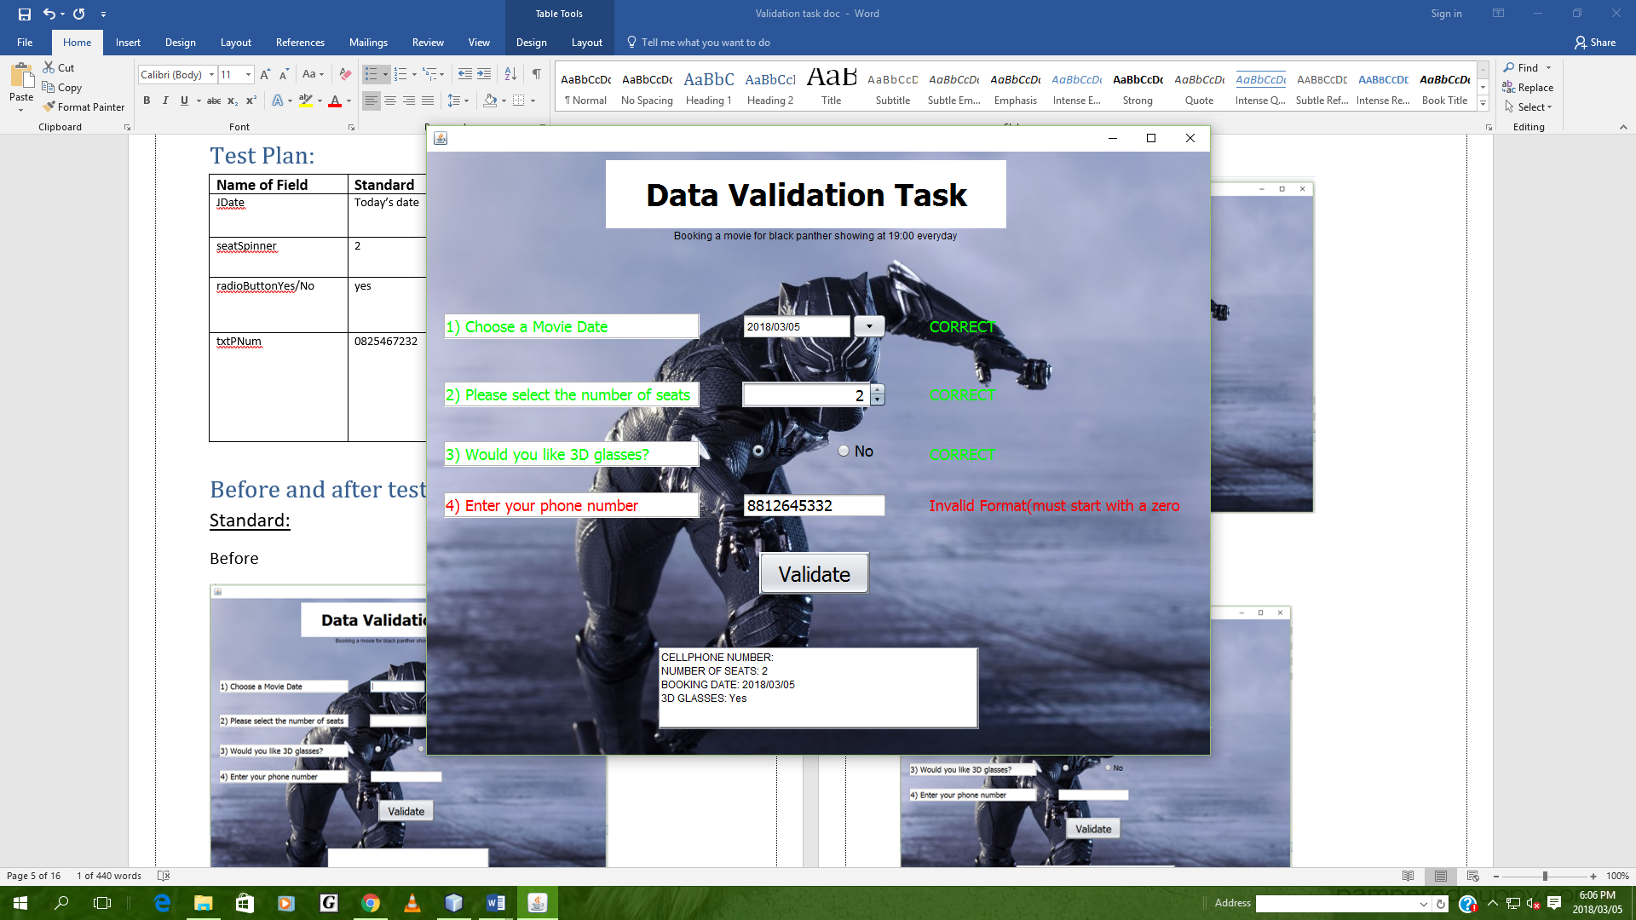

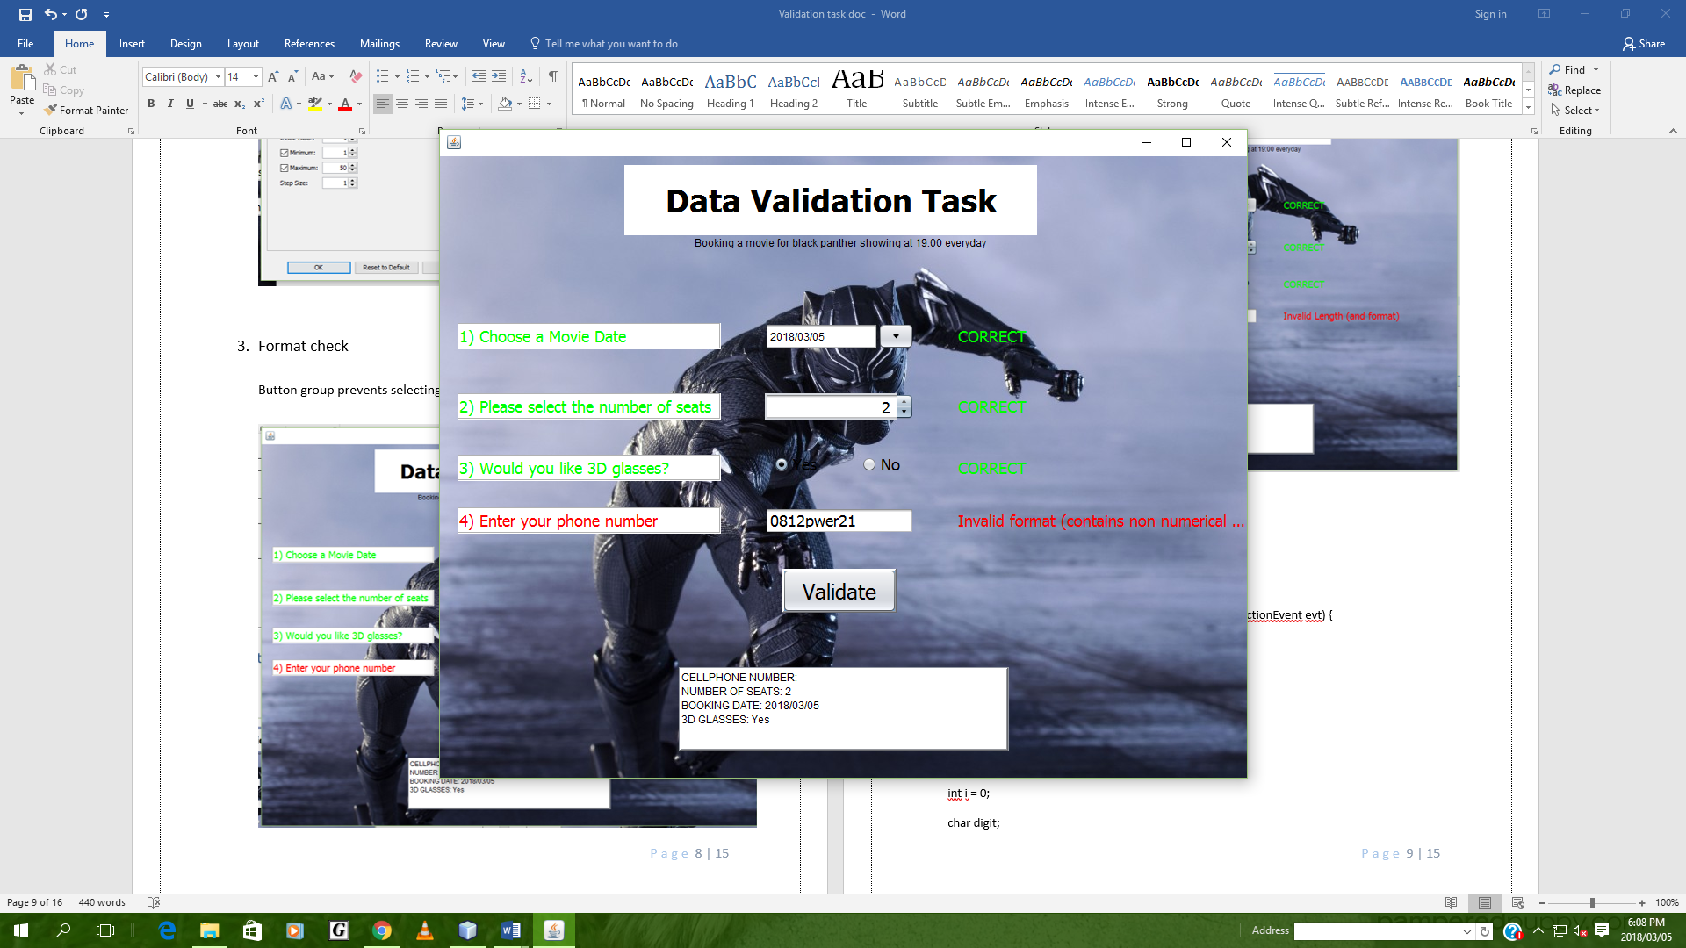

1. Length check

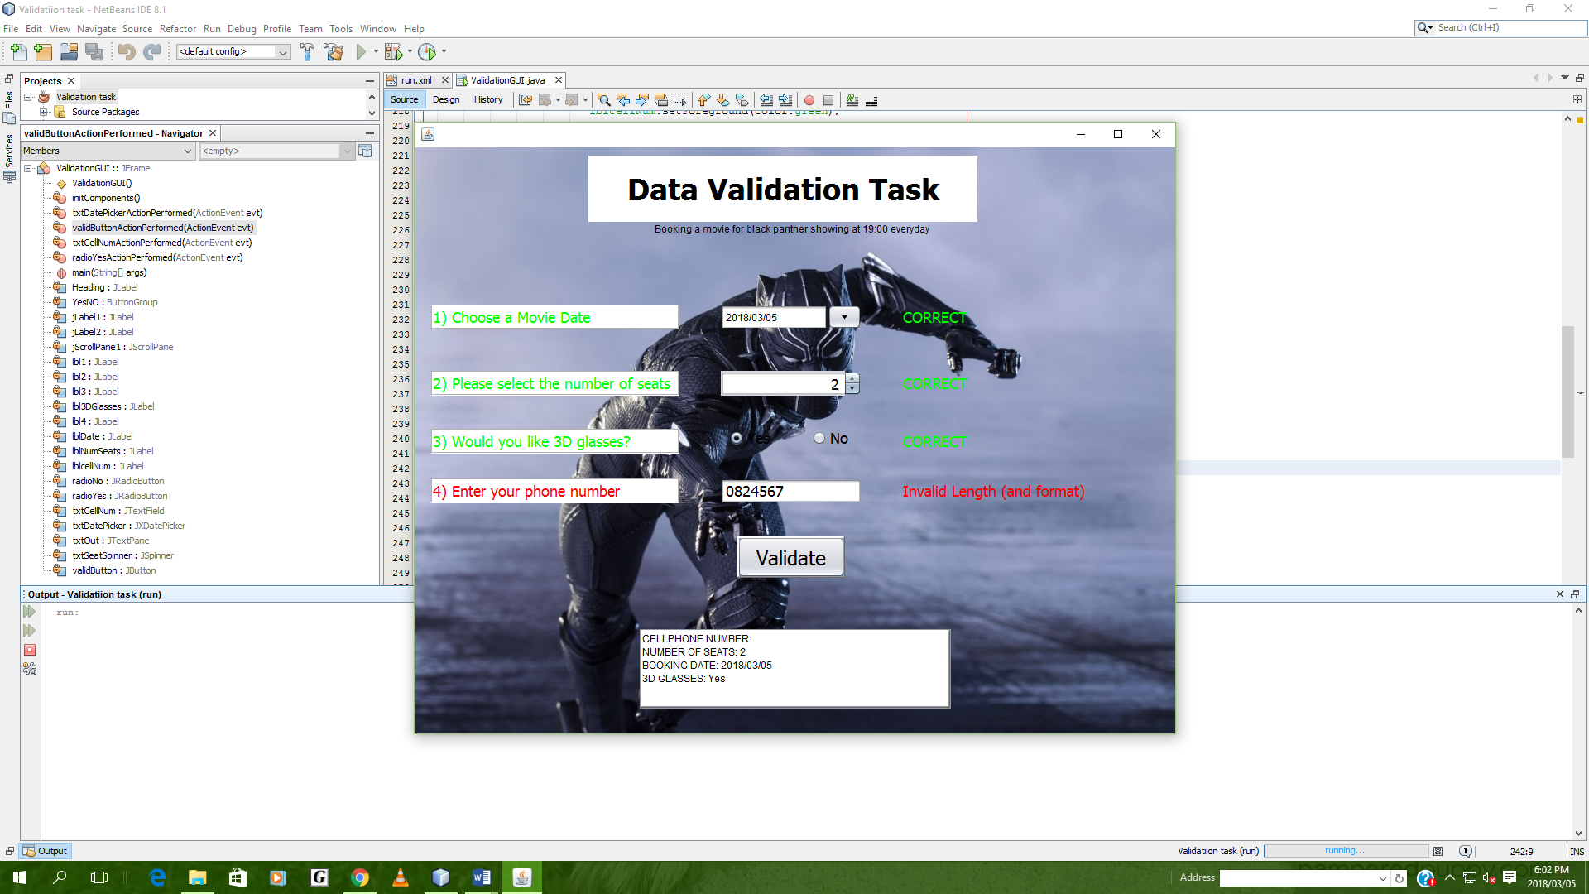

# Coding:

private void validButtonActionPerformed(java.awt.event.ActionEvent evt) {

//cell number

String cellNumber = txtCellNum.getText();

String cellOut = "";

int i = 0;

char digit;

Boolean stat = true;

int len = cellNumber.length();

if(!cellNumber.equals(""))

{

if(len == 10)

{

if(cellNumber.charAt(0) == '0')

{

while(i < 10 & stat == true)

{

digit = cellNumber.charAt(i);

if(digit >= 48 & digit <= 57)

{

}

else

{

stat = false;

}

i++;

}

if (stat == true)

{

cellOut = cellNumber;

lbl1.setText("CORRECT");

lblcellNum.setForeground(Color.green);

lbl1.setForeground(Color.green);

}

else

{

lbl1.setText("Invalid format (contains non numerical values)");

lblcellNum.setForeground(Color.red);

lbl1.setForeground(Color.red);

}

}

else

{

lbl1.setText("Invalid Format(must start with a zero"); //format check

lblcellNum.setForeground(Color.red);

lbl1.setForeground(Color.red);

}

}

else

{

lbl1.setText("Invalid Length and format");

lblcellNum.setForeground(Color.red);

lbl1.setForeground(Color.red);

}

}

else

{

lbl1.setText("Please enter a cellphone number");

lblcellNum.setForeground(Color.red);

lbl1.setForeground(Color.red);

}

//cell number

//Height

int seats = Integer.parseInt(txtSeatSpinner.getValue() + "");

String outSeats = "";

if(seats <= 20)

{

lbl3.setText("CORRECT");

lbl3.setForeground(Color.green);

lblNumSeats.setForeground(Color.green);

outSeats = seats + "";

}

else

{

lbl3.setText("You cannot Book more then 20 seats at a time");

lbl3.setForeground(Color.red);

lblNumSeats.setForeground(Color.red);

} //height// Range check

//BUTTONGROUP

String option = "";

if(radioYes.isSelected())

{

option = "Yes";

lbl4.setText("CORRECT");

lbl4.setForeground(Color.green);

lbl3DGlasses.setForeground(Color.green);

}

else

if(radioNo.isSelected())

{

option = "No";

lbl4.setText("CORRECT");

lbl4.setForeground(Color.green);

lbl3DGlasses.setForeground(Color.green);

}

else

{

lbl4.setText("Please Choose an option");

lbl4.setForeground(Color.red);

lbl3DGlasses.setForeground(Color.red); //precence check

}

//BUTTONGROUP

String dtOut = "";

String dtChoice = "";

String current = "";

//DATEPICKER

// String Date1 = datePicker.getDate();

try

{

DateFormat dtForm = new SimpleDateFormat("yyyy/MM/dd"); // precence check

Date dtIn = txtDatePicker.getDate();

Date dtNow = new Date();

current = dtForm.format(dtNow);

dtOut = dtForm.format(dtIn);

if(dtOut.compareTo(current) >= 0)

{

dtChoice = dtOut;

lbl2.setText("CORRECT");

lbl2.setForeground(Color.green);

lblDate.setForeground(Color.green);

}

else

{

lbl2.setText("Cannot choose a past date");

lbl2.setForeground(Color.red);

lblDate.setForeground(Color.red);

}

}

catch(java.lang.NullPointerException e)

{

lbl2.setText("Enter a Movie Date");

lbl2.setForeground(Color.red);

lblDate.setForeground(Color.red);

}

// DatePicker

txtOut.setText("CELLPHONE NUMBER: " + cellOut + "\nNUMBER OF SEATS: " + outSeats + "\nBOOKING DATE: " + dtChoice + "\n3D GLASSES: " + option);

}